The PhD student (2023)

Number | Name | Grade | E-mail
1 | 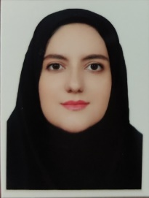  Zahrasadat mousavifard | PhD Student | morid.dostz@gmail.com
2 | 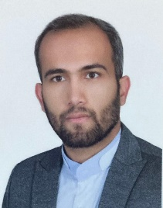Mohammad bagher Aghebat bekheir | PhD Student | mohammadaghebat@yahoo.com
3 | 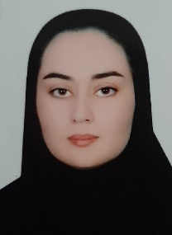  Tahere Eskandari | PhD Student | t.eskandari304@gmail.com
4 | 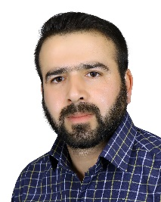  Ghasem Zare | PhD Student | gh.zare1366@gmail.com

